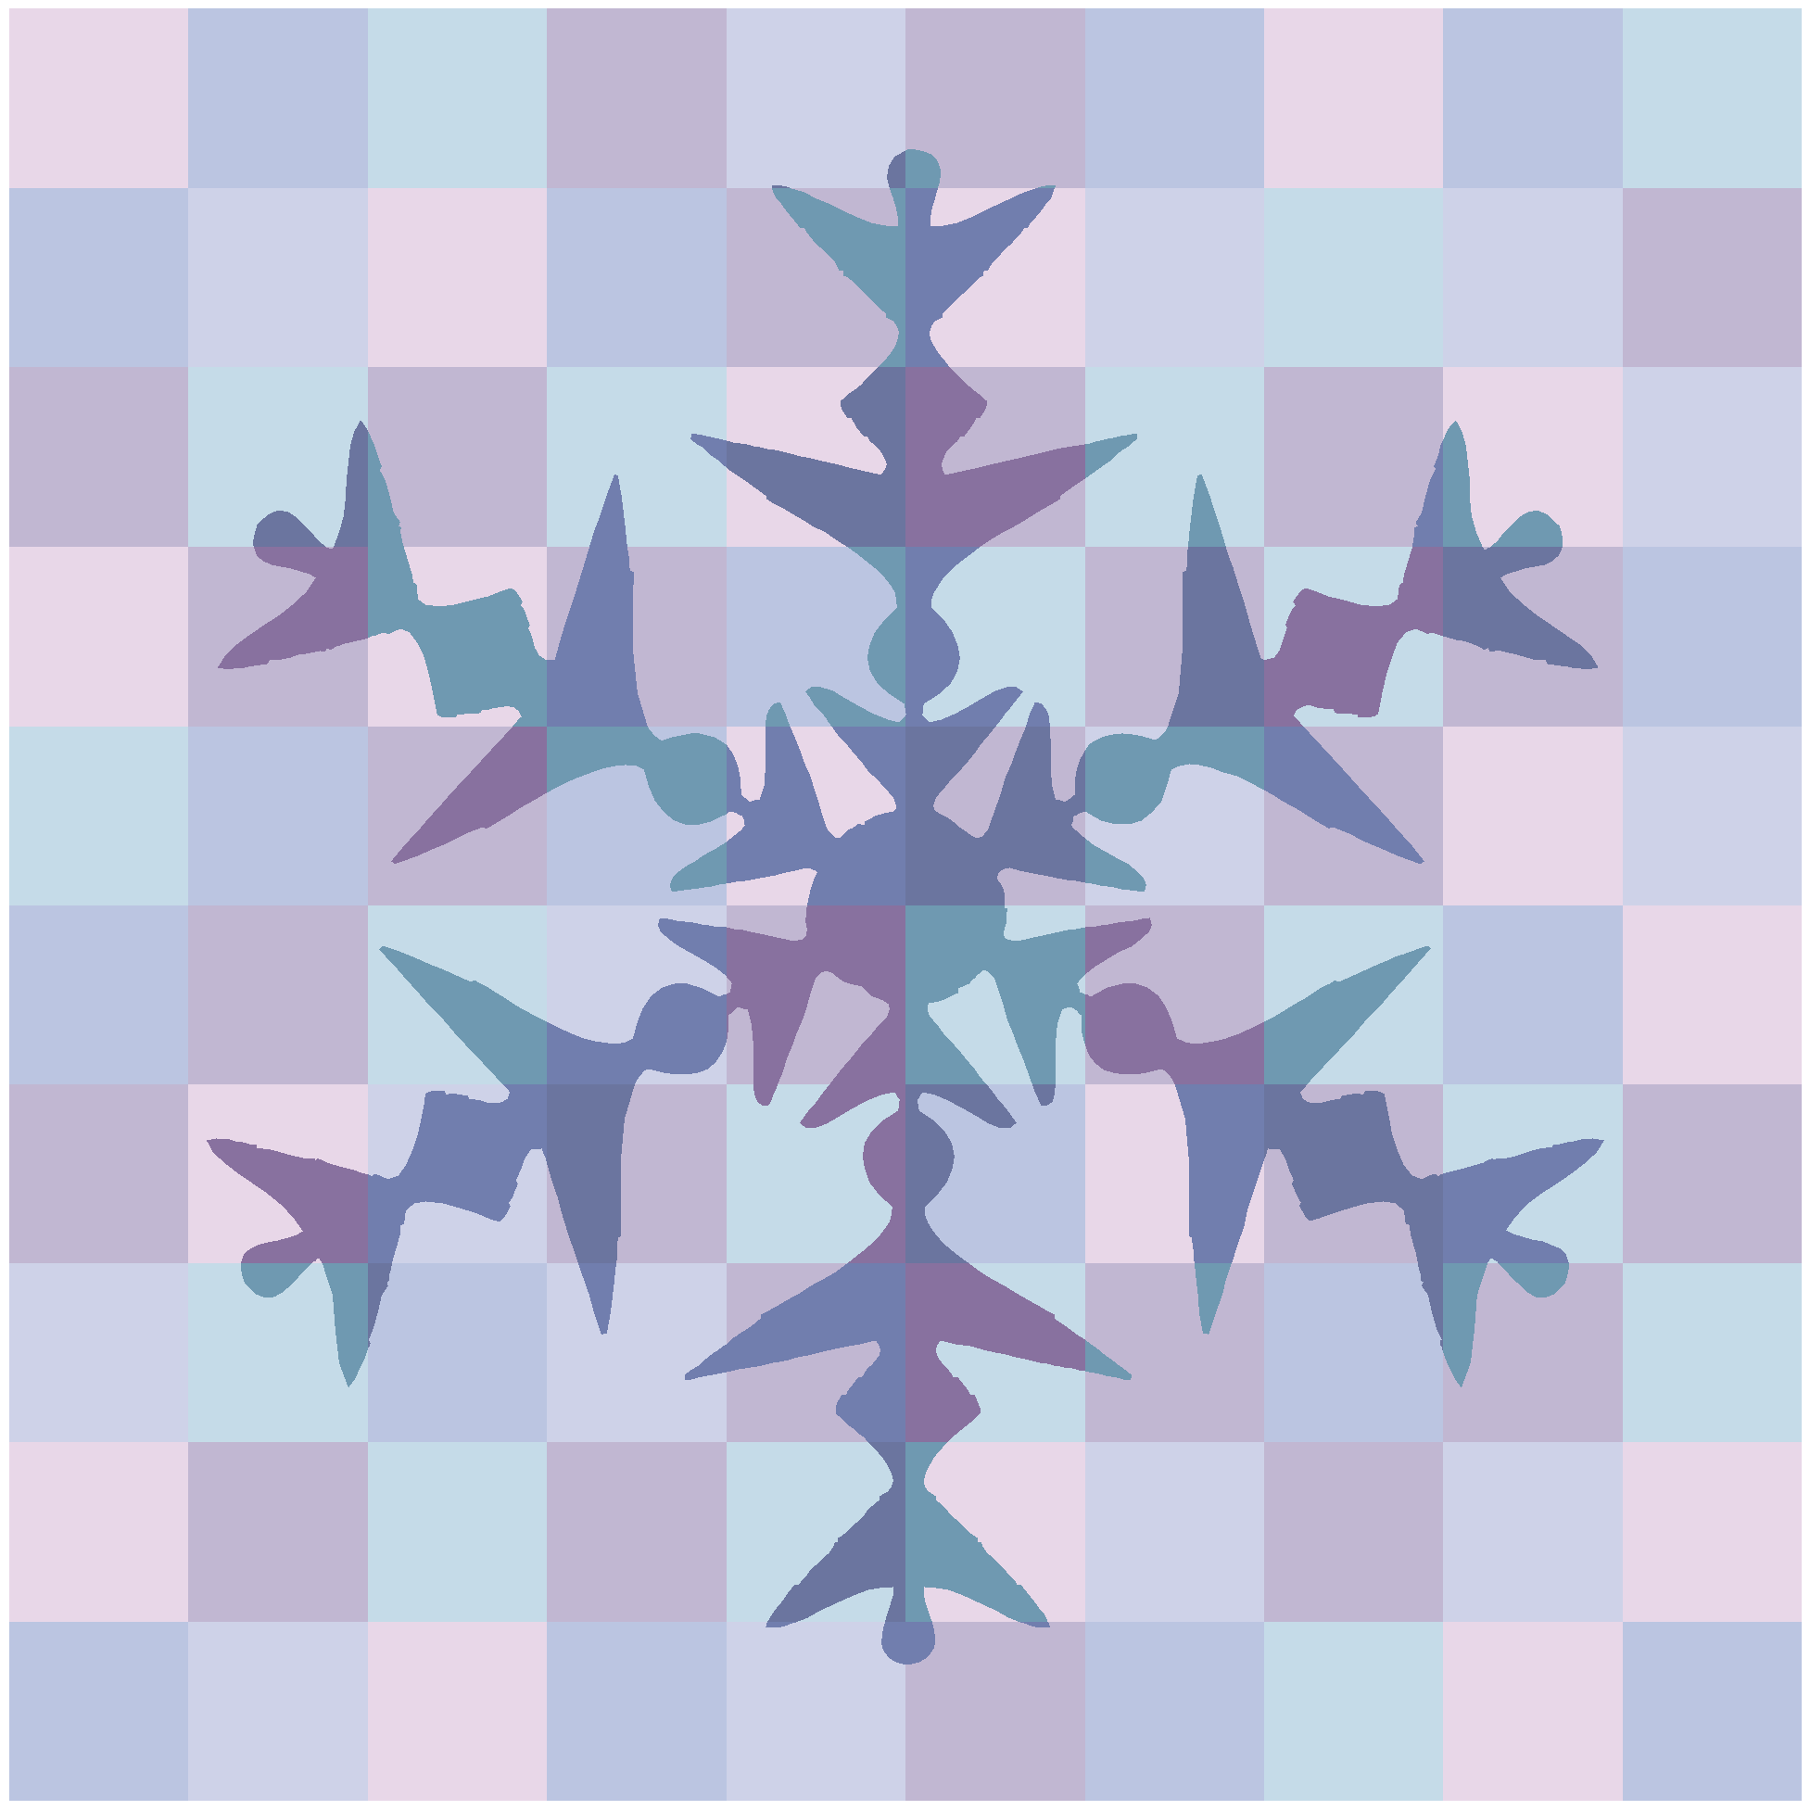

This pack includes some activities you can do

if you are off school because of snow. You do not have to do it all and please make sure you have lots of fun and go outside to play!

If we are off for a longer period of time check the blog for more activities.

Your first activity is to go out and build a snow man! Take a photo of him/her if you can. Please measure how tall your snowman is and write it down so we can see who made the tallest one.

Create an acrostic poem using the word SANTA

S

A

N

T

A

Santa’s elves

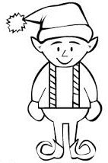

Measure a member of your family for their elf costume. Santa likes his elves to look smart so you need to measure carefully. Measure in centimetres—

and record your answers below.

Measure around their

head, above their ears.

Measure around their neck..

Measure from their shoulder to their wrist.

Measure around their waist..

Measure from their knee to their ankle.

Measure from their heel to their big toe.

Practice your spelling words and some of the spelling patterns we have been practicing this term using some of the tasks below.

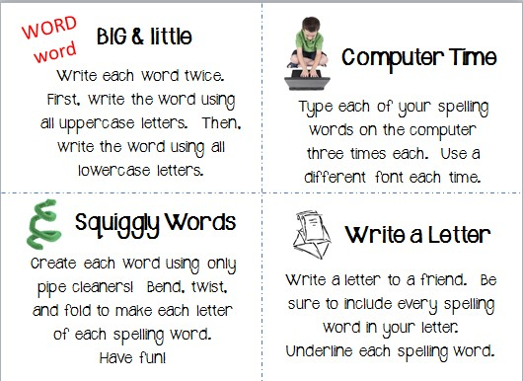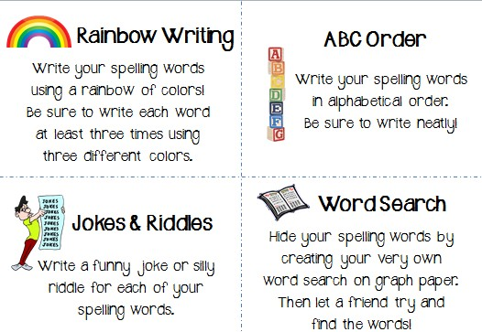

My Film Review

Watch a Christmas movie and write a review of it.

Draw a picture of your favourite scene part of the movie.

Who is the story about?

What happens in it?

How does it end?

Make a delicious hot chocolate to warm you up after playing in the snow -

write a set of instructions to explain how you did it.

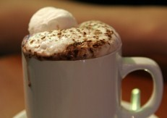

How to

1

2

3

4

5

6

7

8

Some other activities.

Family baking and cooking projects are excellent opportunities

for students to practice reading and following directions, weights and measurements. Plus everyone can enjoy the re- sults.

Create a diary entry about your snow day. What did you do?

How were you feeling? What was your favourite part? What are you looking forward to?

Write a list of questions to your favourite Christmas character

using a different question starter for each one.

Draw a picture of your favourite snow activity—write a sentence underneath explaining why that is your favourite.

Most of all HAVE FUN! Get

outside and enjoy the snow while it is here.

